**COMSATS UNVERISTY ISLAMABAD**



**Artificial Intelligence**

**Lab 11**

**Submitted by:**

Hasaan Ahmad SP22-BSE-017

**Submitted to:**

**Sir Waqas Ali**

**Activity 1:**

**Code:**

from constraint import Problem, AllDifferentConstraint

regions = ["Western Australia", "Northern Territory", "South Australia", "Queensland", "New South Wales", "Victoria", "Tasmania"]

colors = ["red", "green", "blue"]

neighbors = [("Western Australia", "Northern Territory"), ("Western Australia", "South Australia"), ("South Australia", "Northern Territory"),

             ("Queensland", "Northern Territory"), ("Queensland", "South Australia"), ("Queensland", "New South Wales"),

             ("New South Wales", "South Australia"), ("Victoria", "South Australia"), ("Victoria", "New South Wales"),

             ("Victoria", "Tasmania")]

problem = Problem()

problem.addVariables(regions, colors)

for neighbor in neighbors:

    problem.addConstraint(AllDifferentConstraint(), neighbor)

solutions = problem.getSolutions()

for solution in solutions:

    print(solution)

**Output:**

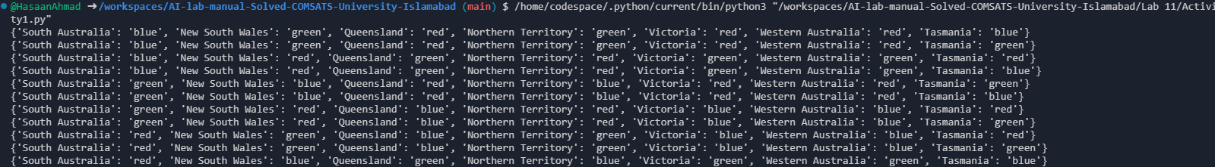

**Activity 2:**

**Code:**

from constraint import Problem, AllDifferentConstraint

problem = Problem()

problem.addVariables(range(4), range(4))

problem.addConstraint(AllDifferentConstraint())

problem.addConstraint(lambda q1, q2, q3, q4: abs(q1 - q2) != 1 and abs(q1 - q3) != 2 and abs(q1 - q4) != 3 and

                                          abs(q2 - q3) != 1 and abs(q2 - q4) != 2 and abs(q3 - q4) != 1,

                                          (0, 1, 2, 3))

solutions = problem.getSolutions()

for solution in solutions:

    print(solution)

**Output:**

